**1.Write a program to display calander program.Given day month year find out which day.**

**Code:-**

/*

Author:-Debayan De

CS791

Checking Date

**\*/**

#include<stdio.h>

#include<math.h>

int fm(int date, int month, int year) {

int fmonth, leap;

//leap function 1 for leap & 0 for non-leap

if ((year % 100 == 0) && (year % 400 != 0))

leap = 0;

else if (year % 4 == 0)

leap = 1;

else

leap = 0;

fmonth = 3 + (2 - leap) * ((month + 2) / (2 * month))

+ (5 * month + month / 9) / 2;

//bring it in range of 0 to 6

fmonth = fmonth % 7;

return fmonth;

}

//----------------------------------------------

int day_of_week(int date, int month, int year) {

int dayOfWeek;

int YY = year % 100;

int century = year / 100;

printf("\nDate: %d/%d/%d \n", date, month, year);

dayOfWeek = 1.25 * YY + fm(date, month, year) + date - 2 * (century % 4);

//remainder on division by 7

dayOfWeek = dayOfWeek % 7;

switch (dayOfWeek) {

case 0:

printf("weekday = Saturday");

break;

case 1:

printf("weekday = Sunday");

break;

case 2:

printf("weekday = Monday");

break;

case 3:

printf("weekday = Tuesday");

break;

case 4:

printf("weekday = Wednesday");

break;

case 5:

printf("weekday = Thursday");

break;

case 6:

printf("weekday = Friday");

break;

default:

printf("Incorrect data");

}

printf("\n");

return 0;

}

//------------------------------------------

int main() {

int date, month, year;

printf("\nEnter the year ");

scanf("%d", &year);

printf("\nEnter the month ");

scanf("%d", &month);

printf("\nEnter the date ");

scanf("%d", &date);

day_of_week(date, month, year);

return 0;

}

**Output:-**

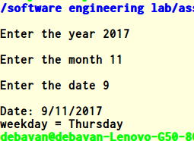

**2.Write a program to find out inverse of 3x3 matrix?**

**Code:-**

/*inverse of 3x3 matrix

*Author:Debayan De

*Cs791

*/

#include<stdio.h>

#include<math.h>

float determinant(float [][25], float);

void cofactor(float [][25], float);

void transpose(float [][25], float [][25], float);

int main()

{

float a[25][25], k, d;

int i, j;

printf("Enter the order of the Matrix : ");

scanf("%f", &k);

printf("Enter the elements of %.0fX%.0f Matrix : \n", k, k);

for (i = 0;i < k; i++)

{

for (j = 0;j < k; j++)

{

scanf("%f", &a[i][j]);

}

}

d = determinant(a, k);

if (d == 0)

printf("\nInverse of Entered Matrix is not possible\n");

else

cofactor(a, k);

}

/*For calculating Determinant of the Matrix */

float determinant(float a[25][25], float k)

{

float s = 1, det = 0, b[25][25];

int i, j, m, n, c;

if (k == 1)

{

return (a[0][0]);

}

else

{

det = 0;

for (c = 0; c < k; c++)

{

m = 0;

n = 0;

for (i = 0;i < k; i++)

{

for (j = 0 ;j < k; j++)

{

b[i][j] = 0;

if (i != 0 && j != c)

{

b[m][n] = a[i][j];

if (n < (k - 2))

n++;

else

{

n = 0;

m++;

}

}

}

}

det = det + s * (a[0][c] * determinant(b, k - 1));

s = -1 * s;

}

}

return (det);

}

void cofactor(float num[25][25], float f)

{

float b[25][25], fac[25][25];

int p, q, m, n, i, j;

for (q = 0;q < f; q++)

{

for (p = 0;p < f; p++)

{

m = 0;

n = 0;

for (i = 0;i < f; i++)

{

for (j = 0;j < f; j++)

{

if (i != q && j != p)

{

b[m][n] = num[i][j];

if (n < (f - 2))

n++;

else

{

n = 0;

m++;

}

}

}

}

fac[q][p] = pow(-1, q + p) * determinant(b, f - 1);

}

}

transpose(num, fac, f);

}

/*Finding transpose of matrix*/

void transpose(float num[25][25], float fac[25][25], float r)

{

int i, j;

float b[25][25], inverse[25][25], d;

for (i = 0;i < r; i++)

{

for (j = 0;j < r; j++)

{

b[i][j] = fac[j][i];

}

}

d = determinant(num, r);

for (i = 0;i < r; i++)

{

for (j = 0;j < r; j++)

{

inverse[i][j] = b[i][j] / d;

}

}

printf("\n\n\nThe inverse of matrix is : \n");

for (i = 0;i < r; i++)

{

for (j = 0;j < r; j++)

{

printf("\t%f", inverse[i][j]);

}

printf("\n");

}

}

**Output:-**

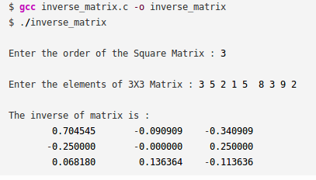

**3.Write a program to check weather a matrix is magic square or not?**

**Code:-**

/*

Author:-Debayan De

CS791

Checking Magic Square

*/

//headers

#include<stdio.h>

#include<stdlib.h>

//function prototypes

void input();

void init(int,int);

void getdata(int);

void validate();

//void rowsum(int**,int);

//void colsum(int**,int);

//global vars

int arr[100][100],size;

//functions

void input(){

int num=0;

printf("Enter magic square size");

scanf("%d",&size);

init(size,num);

printf("enter the elements");

getdata(size);

}

void init(int size,int num)

{

int i,j;

for(i=0;i<size;i++)

{

for(j=0;j<size;j++)

{

arr[i][j]=num;

}

}

}

void getdata(int size)

{

int i,j,num;

for(i=0;i<size;i++)

{

for(j=0;j<size;j++)

{

scanf("%d",&num);

arr[i][j]=num;

}

}

}

void validate()

{

int i,j,k;

int ar[size*2+2];

int arsize=(size*2+2);

for(i=0;i<(size*2+2);i++)

{

ar[i]=0;

}

for(i=0;i<size;i++)

{

ar[i]=rowsum(arr,i);

// printf("%d%d",ar[i],i);

}

for(j=0;j<size;j++)

{

ar[j+i]=colsum(arr,j);

// printf("%d%d",ar[i+j+1],(i+j+1));

}

ar[j+i]=leftdia();

ar[j+i+1]=rightdia();

for(k=0;k<(size*2+2);k++)

{

printf("%d",ar[k]);

}

validmat(ar,arsize);

}

void validmat(int ar[],int arsize)//validation

{

int i,valid=0;

for(i=0;i<arsize-1;i++)

{

if(ar[i]==ar[i+1]){

valid=1;

}else{

valid=0;

}

}

if(valid==1){

printf("This matrix is a magic square\n");

}else{

printf("Not a magic square\n");

}

}

int leftdia() //rightdiagonalsum

{

int i,sum=0;

for(i=0;i<size;i++)

{

sum=sum+arr[i][i];

}

return sum;

}

int rightdia() //leftdiagonal

{

int i,sum=0;

for(i=0;i<size;i++)

{

sum=sum+arr[i][size-1-i];

}

return sum;

}

int rowsum(int arr[100][100],int index) //calculates row sum

{

int i,x=0;

for(i=0;i<size;i++)

{

x=x+arr[index][i];

}

return x;

}

int colsum(int arr[100][100],int index)//calculates sum of the columns

{

int i,x=0;

for(i=0;i<size;i++)

{

x=x+arr[i][index];

}

return x;

}

int main()

{

input();

validate();

return 0;

}

**Output:-**

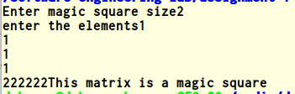

**4.Write a program to read last n characters of a file(Input should be a .txt file)?**

**Code:-**

/*

Author: Debayan De

Name of Assignment:-Write a program to read last n characters from the file

CS791

*/

#include<stdio.h>

int main() {

FILE *fp;

char ch;

int num;

long length;

printf("Enter the value of num : ");

scanf("%d", &num);

fp = fopen("a.txt", "r"); //open the file

if (fp == NULL) {

puts("cannot open this file");

exit(1);

}

fseek(fp, 0, SEEK_END); //set fp to end of file

length = ftell(fp);

fseek(fp, (length - num-2), SEEK_SET);//2 because of EOF

do {

ch = fgetc(fp);

putchar(ch);

} while (ch != EOF);

fclose(fp);

return(0);

}

**Output:-**

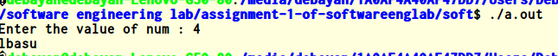

**5.Write a program to print binary numbers pyramid pattern?**

**Code:-**

/*

*Author:Debayan De

*Write Pattern to print banary seq

*cs791 Software Engineering

*Date:-16 sep 2017

*/

//header

#include<stdio.h>

#include<stdlib.h>

//function

int main()

{

int n,i,j,k;

printf("Enter the number of lines\n");

scanf("%d",&n);

k=1;

for(i=0;i<n;i++)

{

for(j=0;j<=i;j++)

{

printf("%d",k);

if(k==1){

k=0;

}else{

k=1;

}

}

printf("\n");

}

return 0;

}

**Output:-**

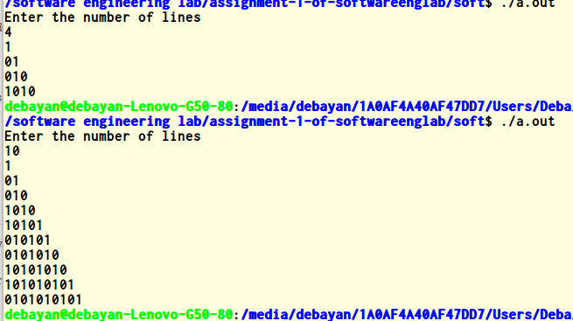

**6.Write a program of input password validation for a user name?**

**Code:-**

/*

*Author:Debayan De

*cs791

*Password validation

*/

// read ASCII password (Unicode not supported)

// uses source code from the example in section 17.7 of the GNU C Library Reference Manual,

// however that example seems to have a bug that I have corrected (I use write instead

// of putchar as otherwise non-canonical mode does not work)

#include <stdio.h>

#include <stdlib.h>

#include <unistd.h>

#include <termios.h>

#include <ctype.h>

/* Use this variable to remember original terminal attributes. */

struct termios saved_attributes;

void

reset_input_mode (void)

{

tcsetattr (STDIN_FILENO, TCSANOW, &saved_attributes);

}

void

set_input_mode (void)

{

struct termios tattr;

char *name;

/* Make sure stdin is a terminal. */

if (!isatty (STDIN_FILENO))

{

fprintf (stderr, "Not a terminal.\n");

exit (EXIT_FAILURE);

}

/* Save the terminal attributes so we can restore them later. */

tcgetattr (STDIN_FILENO, &saved_attributes);

atexit (reset_input_mode);

/* Set the funny terminal modes. */

tcgetattr (STDIN_FILENO, &tattr);

tattr.c_lflag &= ~(ICANON | ECHO); /* Clear ICANON and ECHO. */

tattr.c_cc[VMIN] = 1;

tattr.c_cc[VTIME] = 0;

tcsetattr (STDIN_FILENO, TCSAFLUSH, &tattr);

}

int

main ()

{

int i = 0;

char c, password[100], asterisk = '*';

set_input_mode ();

while (read (STDIN_FILENO, &c, 1) && (isalnum (c) || ispunct (c))

&& i < sizeof (password) - 2)

{

password[i++] = c;

write (STDOUT_FILENO, &asterisk, 1);

}

password[i] = 0;

printf ("\nPassword was: [%s]\n", password);

return EXIT_SUCCESS;

}

**Output:-**

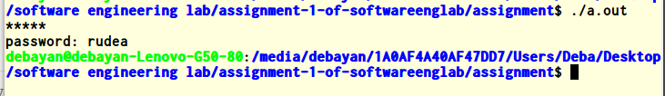

**7.Write a program to create own header file in c?**

**Code:-**

/*

Author:Debayan De

Create own header file

CS701

*/

#include<stdio.h>

#include"myhead.h"

int main()

{

int a=5,b=10;

printf("The ans is:-%d\n",add(a,b));

return 0;

}

//header file

int add(int x,int y)

{

return (x+y);

}

**Output:-**

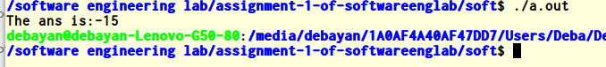

**8.Write a program to compare two strings without using strcmp?**

**Code:-**

/*

*Author:Debayan De

*Comapare two strings without using strcmp

*cs791

*/

#include <stdio.h>

#include <string.h>

#include <stdlib.h>

int check(char* s1, char* s2, int len1, int len2)

{

if (len1 != len2) {

printf("Not equal\n");

return 1;

}

for (int i = 0; i < len1; i++) {

if (s1[i] != s2[i]) {

printf("Not equal\n");

return 1;

}

}

printf("Equal\n");

return 0;

}

int main()

{

int len1, len2;

printf("Enter length of first string: ");

scanf("%d", &len1);

printf("Enter the first string: ");

char* s1 = (char *)malloc((len1 + 1) * sizeof(char));

scanf("%s", s1);

printf("Enter length of second string: ");

scanf("%d", &len2);

printf("Enter the second string: ");

char* s2 = (char *)malloc((len2 + 1) * sizeof(char));

scanf("%s", s2);

check(s1, s2, len1, len2);

return 0;

}

**Output:-**

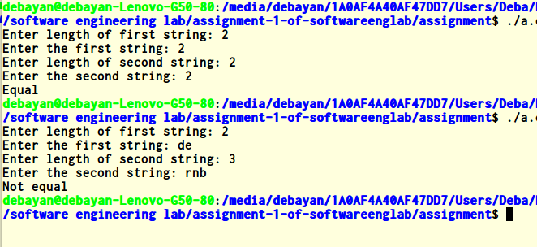

**9.Write a program to print the rectangle using line and special symbols?**

**Code:-**

/*

*Author:Debayan De

*Print rectangle using line and special symbols

*cs791

*/

#include <locale.h>

#include <stdio.h>

#include <wchar.h>

#define DIM 10

int main(void)

{

setlocale(LC_ALL, "");

for (int i = 0; i < DIM; i++) {

printf("%lc", (wint_t)9650);

}

printf("\n");

for (int j = 0; j < DIM; j++) {

for (int i = 0; i < DIM; i++) {

if (i == 0 || i == DIM -1) {

printf("%lc", (wint_t)9650);

if (i == DIM - 1) {

printf("\n");

}

} else {

printf("-");

}

}

}

for (int i = 0; i < DIM; i++) {

printf("%lc", (wint_t)9650);

}

printf("\n");

return 0;

}

**Output:-**

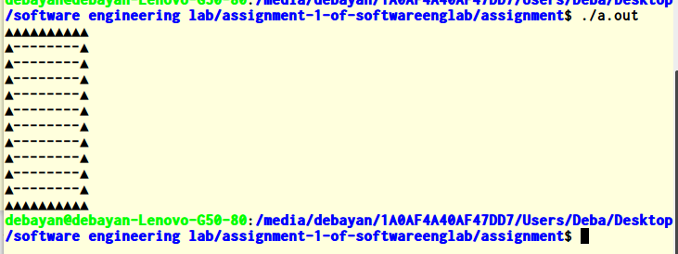

**10.Write a program to find addition of Lower Triangular Matrix?**

**Code:-**

/*

*Author:Debayan De

*Addition of lower triangular matrix

*cs791

*/

#include <stdio.h>

#include <stdlib.h>

int main()

{

int i, j;

int size;

printf("Enter size: ");

scanf("%d", &size);

int **a = (int **) malloc(size * sizeof(int *));

for (i = 0; i < size; i++) {

a[i] = (int *)malloc(size * sizeof(int));

}

printf("Enter the elements\n");

for (i = 0; i < size; i++) {

for (j = 0; j < size; j++) {

scanf("%d", &a[i][j]);

}

}

for (i = 0; i < size; i++) {

for (j = 0; j < size; j++) {

if (i + j < size - 1) {

printf(" ");

} else {

printf("%d ", a[i][j]);

}

}

printf("\n");

}

return 0;

}

**Output:-**

